Refer to the given schema.

  Write a single query to update the TARGET_POLICY_SUM column values in T_AGENT table, based on following criteria:

-         IF the AGENT_CITY is 'PUNE' and the AGENT_ID starts with M then update the TARGET_POLICY_SUM to 400000

-         OR IF THE AGENT CITY is 'CHENNAI' and the AGENT_ID with M then update the TARGET_POLICY_SUM to 250000

Design Rules:

1.       You must write ONE update query to update the table.

(Note: Evaluate only the respective DML query to get the desired results. Data is case sensitive)

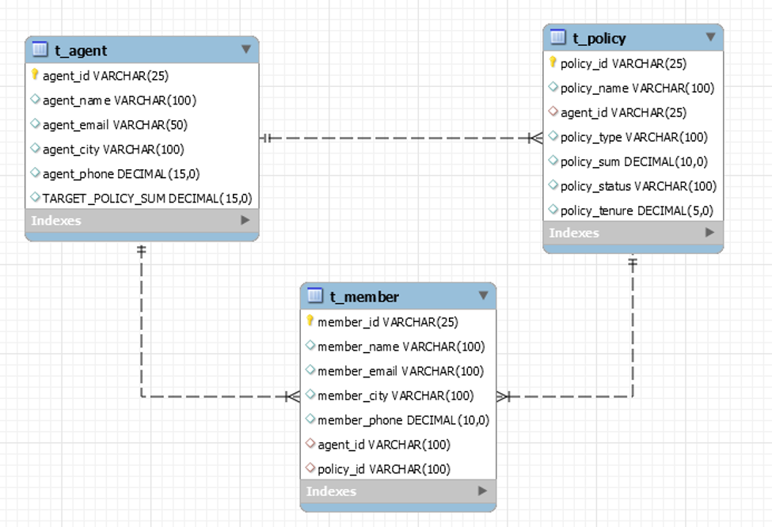

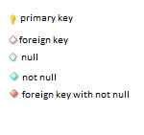

insert into t_agent values('8101', 'Ritik', 'abc', 'pune', 123, 5000);

insert into t_agent values('3102', ' Ritik ', ' abc ', 'chennai', 123, 80);

insert into t_agent values('4103', ' Ritik ', ' abc ', 'pune', 123, 4000);

insert into t_agent values('7104', ' Ritik ', ' abc ', 'pune', 123, 6000);

select * from t_agent;

**UPDATE T_AGENT**

**SET TARGET_POLICY_SUM = CASE**

**WHEN AGENT_CITY = 'PUNE' AND AGENT_ID LIKE ‘M%’ THEN 400000**

**WHEN AGENT_CITY = ‘CHENNAI’ AND AGENT_ID LIKE ‘M%’ THEN 250000**

**ELSE TARGET_POLICY_SUM**

**END**

**WHERE AGENT_CITY IN ('PUNE', 'CHENNAI',)**